January 2024
Activities & Scheduled Happenings
 |  |  |  |  |  | 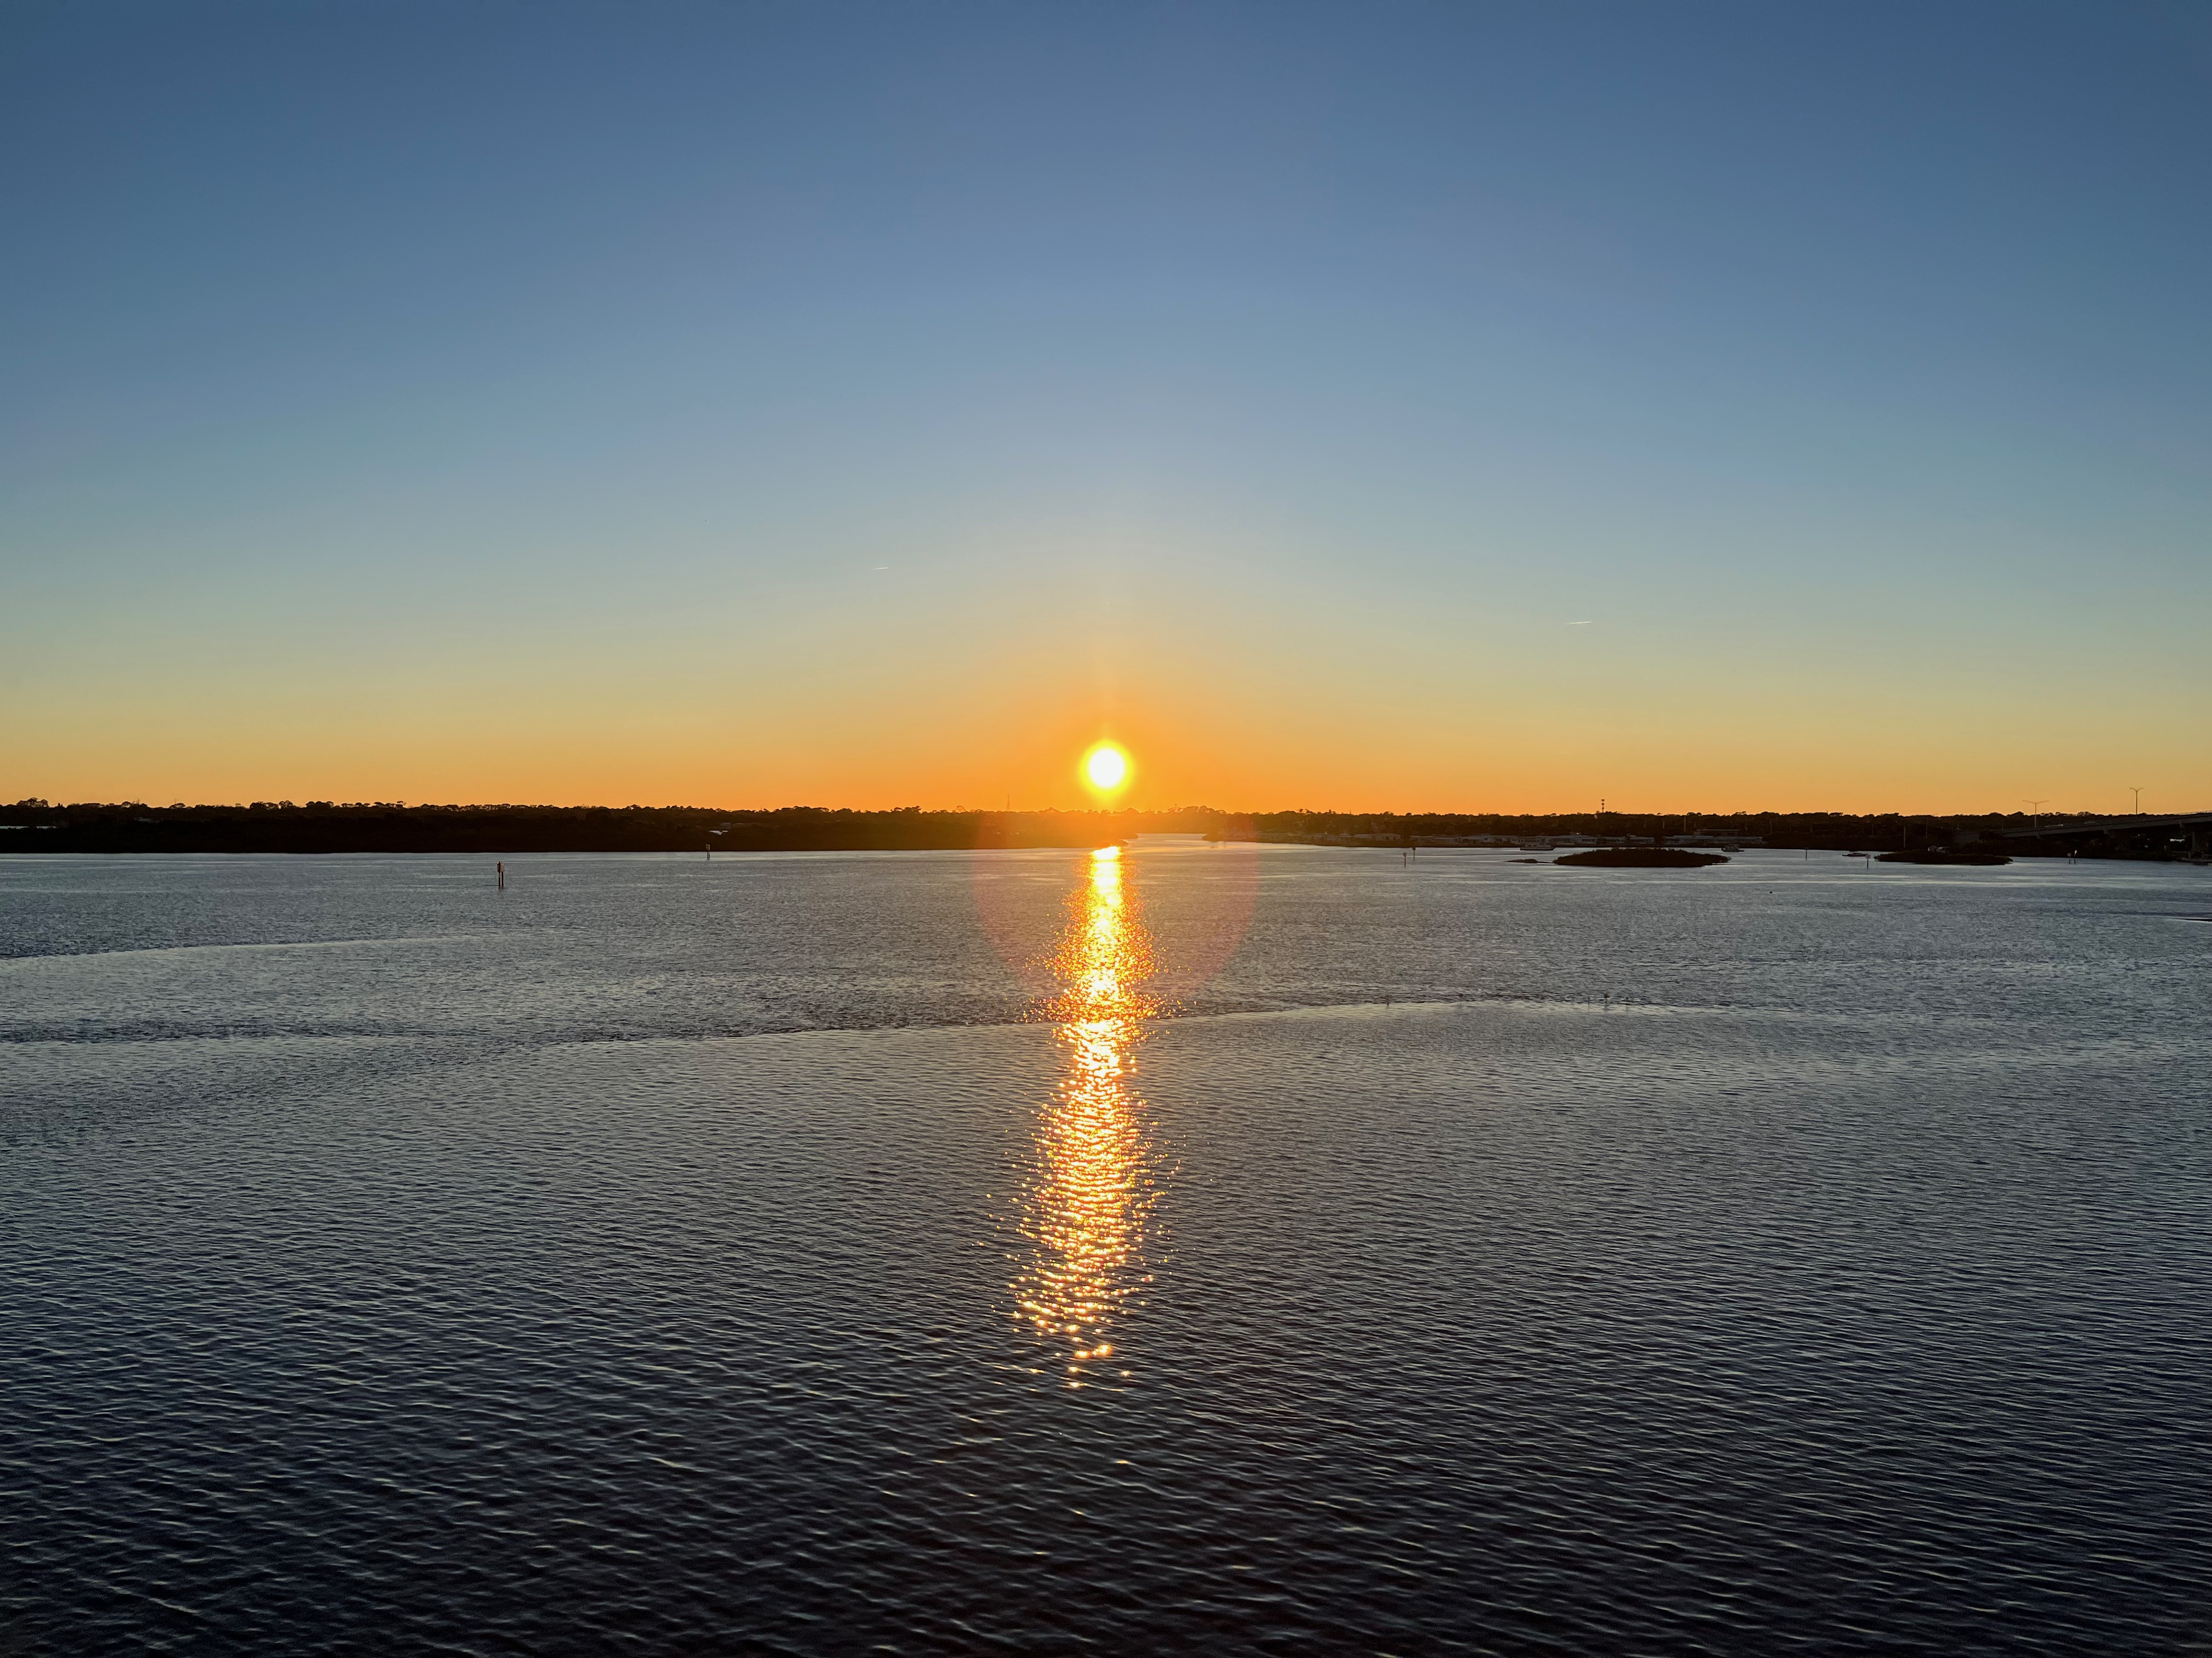
Sunday |  | Monday | Tuesday | Wednesday | Thursday |  | Friday | Saturday
 |  | 1  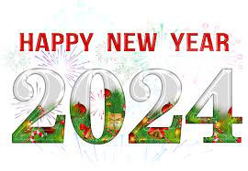 | 2 | 3  5:15 - 6:00pm | 4  5:00-7:00pm |  | 5  9:30-10:15am  Pest Control  3rd fl. | 6
7  10am Undecorate the Lounge |  | 8  9:30-10:15am | 9  8:00 Annual Board Meeting | 10  Quarters  9am - 10am  6pm-7pm  5:15 - 6:00pm | 11  5:00-7:00pm |  | 12  9:30-10:15am | 13
Pest Control
4th fl.

14 |  | 15  Martin Luther King Jr. Day  9:30-10:15am | 16  6:00 | 17  5:15 - 6:00pm | 18  5:00-7:00pm |  | 19  9:30-10:15am  Pest Control  5th fl. | 20
21 |  | 22  9:30-10:15am | 23 | 24 | 25 |  | 26 | 27
 |  |  |  | Yard Sale Prep  8am to 12 noon 5pm to 7pm  Lounge closed. | Yard Sale Prep  8am to 12 noon  5pm to 7pm  Lounge closed |  | Yard Sale  Residents only  5pm to 7pm  Lounge closed.  Pest Control  6th fl. | Yard Sale for  Residents  &  Public  8am to 3pm  Lounge closed
28  Yard Sale for  Residents  &  Public  9am to 1pm  Lounge closed |  | 29  9:30-10:15am | 30 | 31  5:15 - 6:00pm

February 2024
Planned Activities and Happenings
 |  |  |  |  |  | 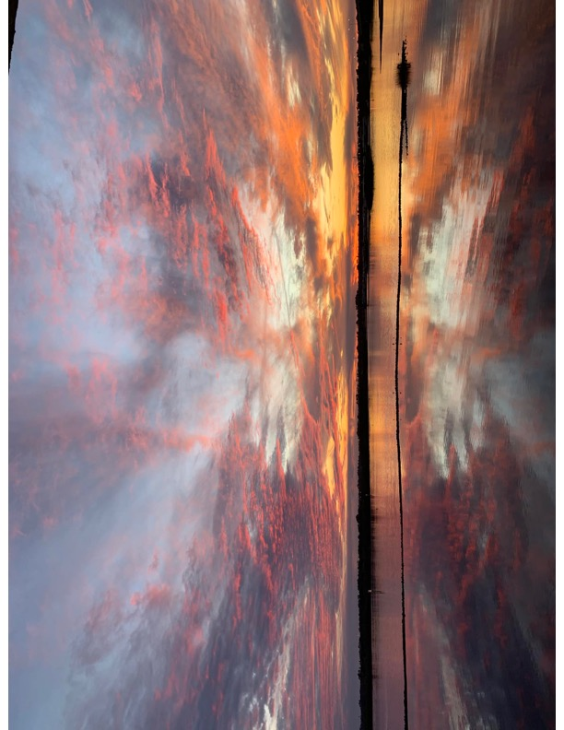
Sunday |  | Monday | Tuesday | Wednesday | Thursday |  | Friday | Saturday
 |  |  |  |  | 1  5:00pm  Happy Hour |  | 2  9:30 to 10:15am | 3
 |  |  |  |  |  |  | Pest Control 7th fl.
4 |  | 5  9:30 to 10:15am | 6 | 7  5:15 - 6:00pm | 8  5:00pm  Happy Hour |  | 9  9:30 to 10:15am  Pest Control 8th fl. | 10
11  5:30pm  Super Bowl Party 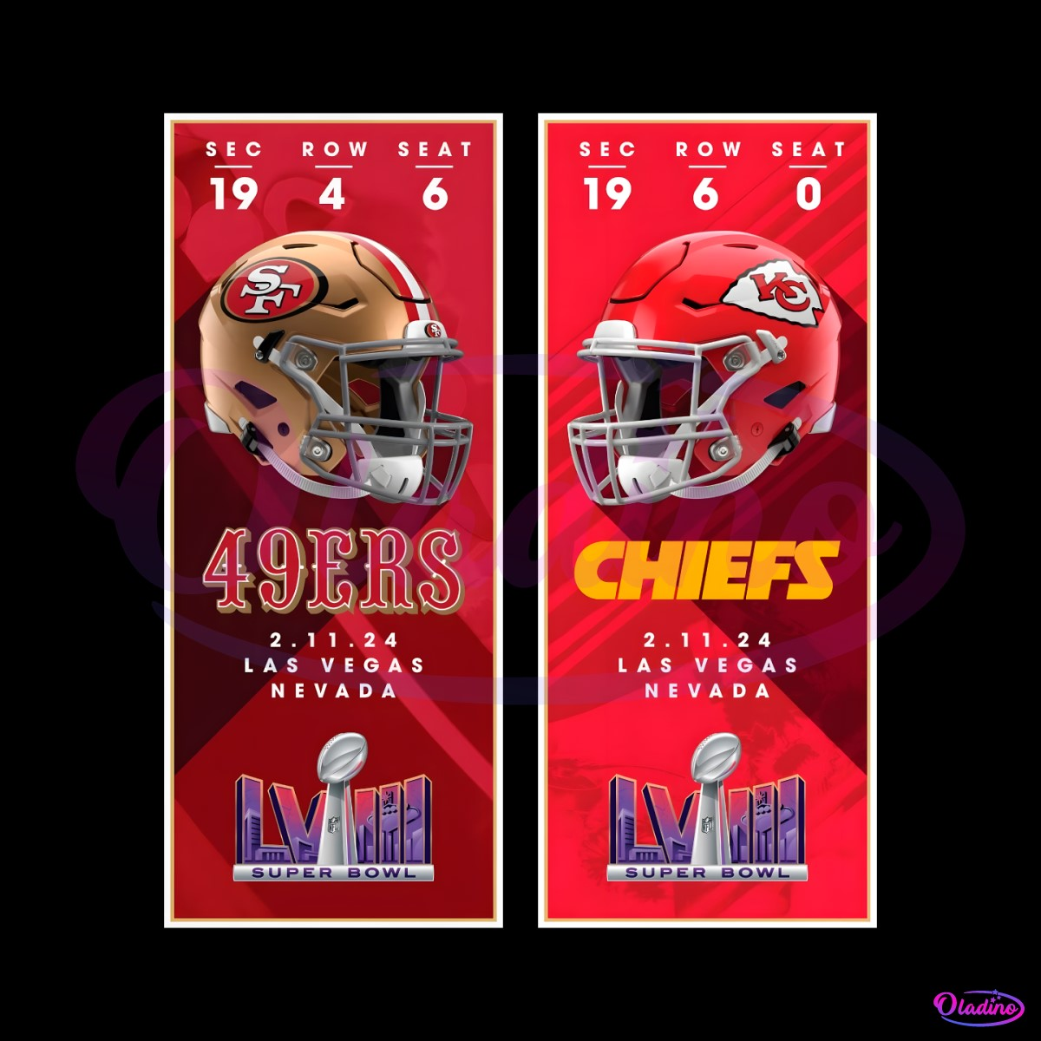  Chili Cook Off 50/50 |  | 12  9:30 to 10:15am | 13 | Ash Wednesday 14  Quarters  9-10am 6-7pm  5:15 - 6:00pm | 15  5:00pm  Valentines  Happy Hour |  | 16  9:30 to 10:15am  Pest Control 1st fl. | 17
18 |  | 19  Presidents Day  9:30 to 10:15am | 20  6:00 - 7:00pm | 21  Lounge closed for upholstery cleaning  5:15 - 6:00p | 22  5:00pm  Happy Hour |  | 23  9:30 to 10:15am  Pest Control 2nd fl.  7:00pm Unbroken | 24
25 |  | 26  9:30 to 10:15am | 27 | 28  5:15 - 6:00pm | 29  5:00pm  Happy Hour

March 2024
Activities and Scheduled Happenings
Sunday |  | Monday | Tuesday | Wednesday | Thursday |  | Friday | Saturday
 |  |  |  |  |  |  | 1  9:30-10:15am  Pest Control 3rd fl. | 2
3 |  | 4  9:30-10:15am | 5 | 6  5:15 - 6:00pm | 7  5:00pm |  | 8  9:30-10:15am  Pest Control 4th fl. | 9
10  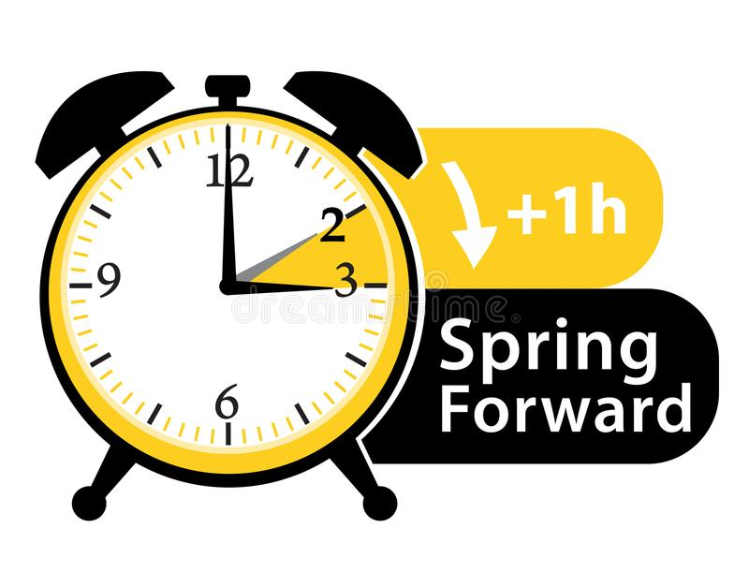 |  | 11  9:30-10:15am | 12 | 13  Quarters  9-10am 6-7pm  5:15 - 6:00pm | 14  5 :00pm  St. Patrick’s Happy Hour  50/50 & LCR |  | 15  9:30-10:15am  Pest Control 5th fl. | 16
17  St. Patrick’s Day |  | 18  9:30-10:15am | 19 | 20  5:15 - 6:00pm | 21  5:00pm |  | 22  9:30-10:15am  Pest Control 6th fl. | 23
24 |  | 25  9:30-10:15am | 26  6:00-7:00 | 27  5:15 - 6:00pm | 28  5:00pm  Easter Happy Hour  50/50 & LCR  7:00 Social Committee Mtg |  | 29  Good Friday  9:30-10:15am  Pest Control 7th fl. | 30
31

April 2023
Activities & Scheduled Happenings
 |  |  |  |  |  | 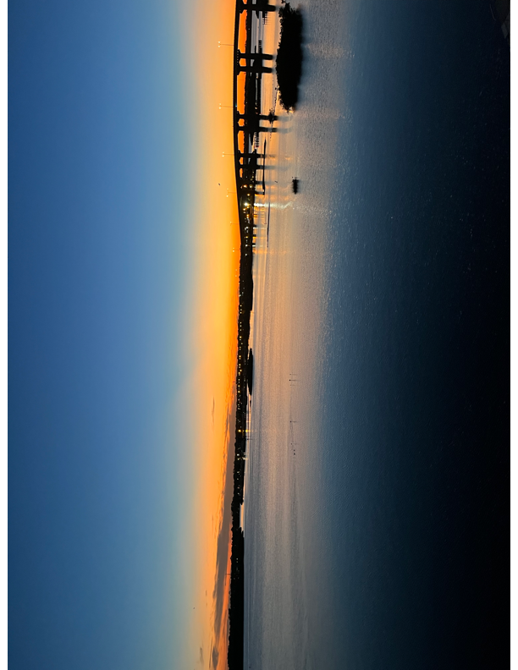
Sunday |  | Monday | Tuesday | Wednesday | Thursday |  | Friday | Saturday
 |  | 1  9:30-10:15am | 2 | 3  5:15 - 6:00pm | 4  Polish Happy Hour  5:00  50/50 LCR |  | 5  9:30-10:15am  Pest Control 8th fl. | 6
7 |  | 8 | 9 | 10 | 11  5:00 |  | 12 | 13
 |  | 9:30-10:15am |  | Quarters  9-10am 6-7pm  5:15 – 6:00pm |  |  | 9:30-10:15am  Pest Control 1st fl.
14 |  | 15  9:30-10:15am | 16 | 17  5:15 - 6:00pm | 18  5:00  & Condo Crawl  sign up & pay |  | 19  9:30-10:15am  Pest Control 2nd fl. | 20
7:00
Ping Pong Night

21 |  | 22  9:30-10:15am | 23 | 24  5:15 - 6:00pm | 25  5:00  7:00  Social Committee Meeting |  | 26  9:30-10:15am  Pest Control 3rd fl. | 27
3:00
Condo Crawl
Sign up info posted on board
28 |  | 29 | 30  6:00-7:00pm

May
2024
Subtitle
 |  |  |  |  |  | 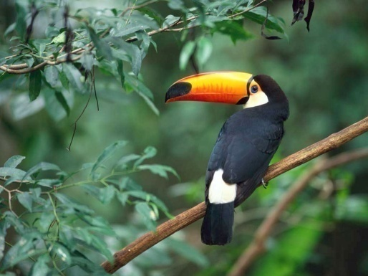

Title
To get started right away, just click any placeholder text (such as this) and start typing to replace it with your own. Want to insert a picture from your files or add a shape? You got it! On the Insert tab of the ribbon, just tap the option you need.
Sunday |  | Monday | Tuesday | Wednesday | Thursday |  | Friday | Saturday
 |  |  |  | 1 | 2 |  | 3 | 4
Coach bus to Hard Rock?
5 |  | 6 | 7 | 8 | 9 |  | 10 | 11
12 |  | 13 | 14 | 15 | 16 |  | 17 | 18
19 |  | 20 | 21 | 22 | 23 |  | 24 | 25
26 |  | 27 | 28 | 29 | 30 |  | 31
View and edit this document in Word on your computer, tablet, or phone. You can edit text; easily insert content such as pictures, shapes, and tables; and seamlessly save the document to the cloud from Word on your Windows, Mac, Android, or iOS device.

June
2024
Subtitle

Title
To get started right away, just click any placeholder text (such as this) and start typing to replace it with your own. Want to insert a picture from your files or add a shape? You got it! On the Insert tab of the ribbon, just tap the option you need.
Sunday |  | Monday | Tuesday | Wednesday | Thursday |  | Friday | Saturday
 |  |  |  |  |  |  |  | 1
2 |  | 3 | 4 | 5 | 6 |  | 7 | 8
9 |  | 10 | 11 | 12 | 13 |  | 14 | 15
16 |  | 17 | 18 | 19 | 20 |  | 21 | 22
23 |  | 24 | 25 | 26 | 27 |  | 28 | 29
30
View and edit this document in Word on your computer, tablet, or phone. You can edit text; easily insert content such as pictures, shapes, and tables; and seamlessly save the document to the cloud from Word on your Windows, Mac, Android, or iOS device.

July
2024
Subtitle

Title
To get started right away, just click any placeholder text (such as this) and start typing to replace it with your own. Want to insert a picture from your files or add a shape? You got it! On the Insert tab of the ribbon, just tap the option you need.
Sunday |  | Monday | Tuesday | Wednesday | Thursday |  | Friday | Saturday
 |  | 1 | 2 | 3 | 4 |  | 5 | 6
7 |  | 8 | 9 | 10 | 11 |  | 12 | 13
14 |  | 15 | 16 | 17 | 18 |  | 19 | 20
21 |  | 22 | 23 | 24 | 25 |  | 26 | 27
28 |  | 29 | 30 | 31
View and edit this document in Word on your computer, tablet, or phone. You can edit text; easily insert content such as pictures, shapes, and tables; and seamlessly save the document to the cloud from Word on your Windows, Mac, Android, or iOS device.

August
2024
Subtitle

Title
To get started right away, just click any placeholder text (such as this) and start typing to replace it with your own. Want to insert a picture from your files or add a shape? You got it! On the Insert tab of the ribbon, just tap the option you need.
Sunday |  | Monday | Tuesday | Wednesday | Thursday |  | Friday | Saturday
 |  |  |  |  | 1 |  | 2 | 3
4 |  | 5 | 6 | 7 | 8 |  | 9 | 10
11 |  | 12 | 13 | 14 | 15 |  | 16 | 17
18 |  | 19 | 20 | 21 | 22 |  | 23 | 24
25 |  | 26 | 27 | 28 | 29 |  | 30 | 31
View and edit this document in Word on your computer, tablet, or phone. You can edit text; easily insert content such as pictures, shapes, and tables; and seamlessly save the document to the cloud from Word on your Windows, Mac, Android, or iOS device.

September
2024
Subtitle

Title
To get started right away, just click any placeholder text (such as this) and start typing to replace it with your own. Want to insert a picture from your files or add a shape? You got it! On the Insert tab of the ribbon, just tap the option you need.
Sunday |  | Monday | Tuesday | Wednesday | Thursday |  | Friday | Saturday
1 |  | 2 | 3 | 4 | 5 |  | 6 | 7
8 |  | 9 | 10 | 11 | 12 |  | 13 | 14
15 |  | 16 | 17 | 18 | 19 |  | 20 | 21
22 |  | 23 | 24 | 25 | 26 |  | 27 | 28
29 |  | 30
View and edit this document in Word on your computer, tablet, or phone. You can edit text; easily insert content such as pictures, shapes, and tables; and seamlessly save the document to the cloud from Word on your Windows, Mac, Android, or iOS device.

October
2024
Subtitle

Title
To get started right away, just click any placeholder text (such as this) and start typing to replace it with your own. Want to insert a picture from your files or add a shape? You got it! On the Insert tab of the ribbon, just tap the option you need.
Sunday |  | Monday | Tuesday | Wednesday | Thursday |  | Friday | Saturday
 |  |  | 1 | 2 | 3 |  | 4 | 5
6 |  | 7 | 8 | 9 | 10 |  | 11 | 12
13 |  | 14 | 15 | 16 | 17 |  | 18 | 19
20 |  | 21 | 22 | 23 | 24 |  | 25 | 26
27 |  | 28 | 29 | 30 | 31
View and edit this document in Word on your computer, tablet, or phone. You can edit text; easily insert content such as pictures, shapes, and tables; and seamlessly save the document to the cloud from Word on your Windows, Mac, Android, or iOS device.

November
2024
Subtitle

Title
To get started right away, just click any placeholder text (such as this) and start typing to replace it with your own. Want to insert a picture from your files or add a shape? You got it! On the Insert tab of the ribbon, just tap the option you need.
Sunday |  | Monday | Tuesday | Wednesday | Thursday |  | Friday | Saturday
 |  |  |  |  |  |  | 1 | 2
3 |  | 4 | 5 | 6 | 7 |  | 8 | 9
10 |  | 11 | 12 | 13 | 14 |  | 15 | 16
17 |  | 18 | 19 | 20 | 21 |  | 22 | 23
24 |  | 25 | 26 | 27 | 28 |  | 29 | 30
View and edit this document in Word on your computer, tablet, or phone. You can edit text; easily insert content such as pictures, shapes, and tables; and seamlessly save the document to the cloud from Word on your Windows, Mac, Android, or iOS device.

December
2024
Subtitle

Title
To get started right away, just click any placeholder text (such as this) and start typing to replace it with your own. Want to insert a picture from your files or add a shape? You got it! On the Insert tab of the ribbon, just tap the option you need.
Sunday |  | Monday | Tuesday | Wednesday | Thursday |  | Friday | Saturday
1 |  | 2 | 3 | 4 | 5 |  | 6 | 7
8 |  | 9 | 10 | 11 | 12 |  | 13 | 14
15 |  | 16 | 17 | 18 | 19 |  | 20 | 21
22 |  | 23 | 24 | 25 | 26 |  | 27 | 28
29 |  | 30 | 31
View and edit this document in Word on your computer, tablet, or phone. You can edit text; easily insert content such as pictures, shapes, and tables; and seamlessly save the document to the cloud from Word on your Windows, Mac, Android, or iOS device.

