January 2026
Planned shenanigans
 | 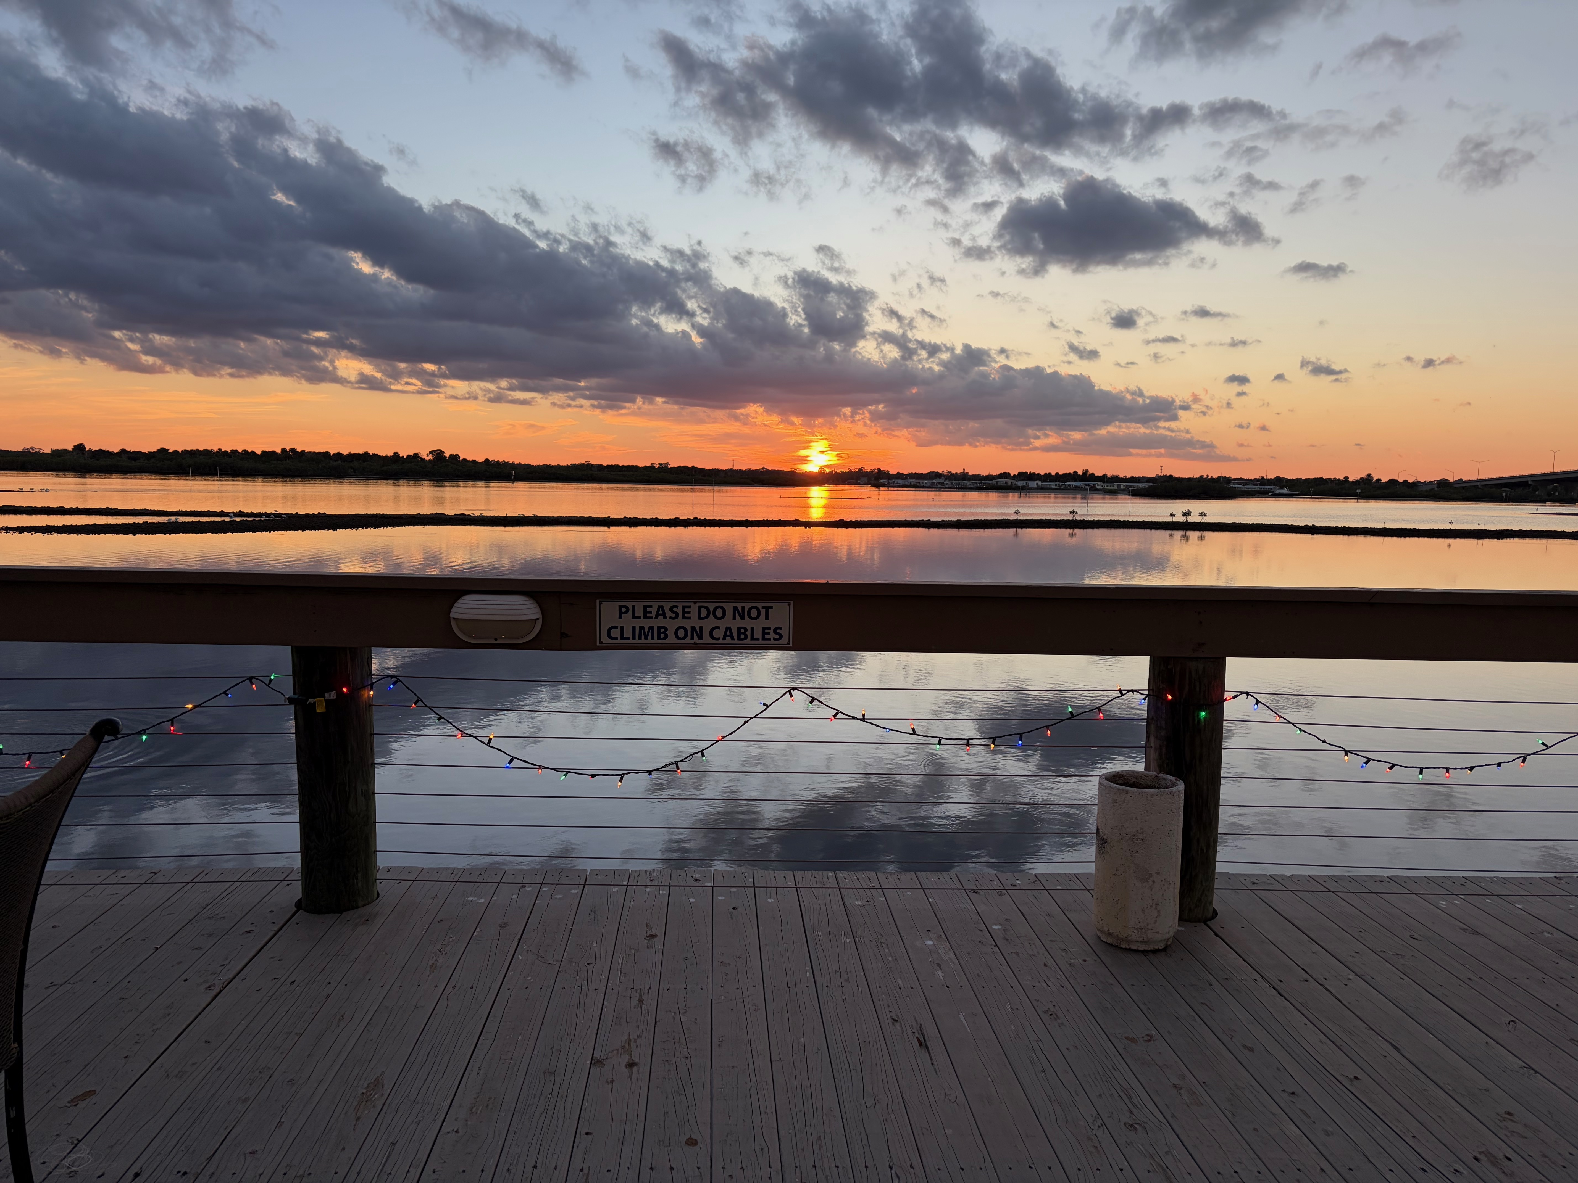
Sunday | Monday | Tuesday | Wednesday | Thursday | Friday | Saturday
 |  |  |  | 1   | 2  9:30-10:15 | 3

Pest Control 7th fl.

4 | 5  9:30-10:15 | 6 | 7  9am Board Meeting  5:15 – 6pm | 8  5:00 Happy Hour   | 9  9:30-10:15 | 10  10am  Meet & Greet New Neighbors  Refreshments will be served
 |  |  |  |  | Pest Control 8th fl.
11 | 12  9:30-10:15 | 13 | 14  5:15 – 6pm | 15 | 16  9:30-10:15  Pest Control 1st fl. | 17
10am  Take down Christmas decorations |  | 8:00 Annual Meeting
18 | 19  Martin Luther King Jr. Day  9:30-10:15 | 20  6:00  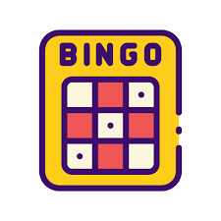 | 21  Yard Sale Prep  8am -12:00  5pm -8:00  Lounge closed | 22  Yard Sale Prep  8am -12:00  5pm -8:00  Lounge closed | 23  Yard Sale  5:00 - 7:00pm  Residents only  Lounge closed  Pest Control 2nd fl. | 24  Yard Sale  Open to All  8am to 3pm  Lounge closed
25  Yard Sale  Open to all  8am to 12pm  Lounge closed | 26  9:30-10:15 | 27 | 28  5:15 – 6pm | 29  Office Closed  5:00 Happy Hour | 30  9:30-10:15 | 31
25  Yard Sale  Open to all  8am to 12pm  Lounge closed |  |  |  |  | Pest Control  3rd fl.

